Master's degree in Entrepreneurship & Project Management

2023 INTAKE

Application deadline: Friday 1st September 2023
Entrance test: 10th September 2023
Start of the academic year: 9th October 2023
Registration fee: 20$ (not refundable), to be paid while submitting application form

Tuition fees: 1600$/Year in one installment or 1700$/Year in two installments (850$/Semester)

Personal Information

Surname and name:
Gender: ⚪ Male ⚪ Female
Date of Birth (dd/mm/yyyy):
Place of Birth:
Nationality:
Current address:
Phone number:
Email Address:
Current status:
⚪ Student
⚪ Employed
⚪ Other
If you are a student, please specify the name of your degree program, the name of the higher education institution and the date of graduation (or expected)

If you are employed, please specify your job position, since when you hold this position and the name of your company/organization

Master's degree year of enrollment

Which year of the master’s degree program do you want to enroll in?
⚪ Year 1 (minimum requirement – holding a bachelor’s degree)
⚪ Year 2 (minimum requirement- a master’s degree year 1 already completed)

Academic Information

Education (Please specify your education details namely the degrees name, the higher education institutions name and the year of completion of any degree you have completed since high school)

Work Experience (Please specify your work experience details, year, job position and company/organization name)

Language Proficiency

English (Self-assess your overall English proficiency on a scale out of 10 points)
 | 0 | 1 | 2 | 3 | 4 | 5 | 6 | 7 | 8 | 9 | 10
 | ⚪ | ⚪ | ⚪ | ⚪ | ⚪ | ⚪ | ⚪ | ⚪ | ⚪ | ⚪ | ⚪

Other languages (Specify the languages and self-assess your overall proficiency on a scale out of 10 points)
 | 0 | 1 | 2 | 3 | 4 | 5 | 6 | 7 | 8 | 9 | 10
……………………………………….. | ⚪ | ⚪ | ⚪ | ⚪ | ⚪ | ⚪ | ⚪ | ⚪ | ⚪ | ⚪ | ⚪
……………………………………….. | ⚪ | ⚪ | ⚪ | ⚪ | ⚪ | ⚪ | ⚪ | ⚪ | ⚪ | ⚪ | ⚪

Miscellaneous

How did you get to know about this Master's degree program?

⚪ Former students
⚪ Friends
⚪ Family
⚪ Media
⚪ Social networks
⚪ Others ……………………………………………..

Supporting documents

To complete your application, please attach the following documents (in one PDF file only with your Name_Surname.pdf as a title):

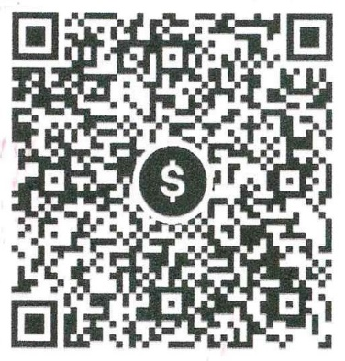
- A resume;
- A photo;
- A copy of ID card or passport;
- A copy of high school diploma;
- A copy of bachelor's degree diploma;
- A copy of bachelor's degree transcripts;
- A copy of master's degree - year 1 transcript or master's degree diploma (only for an enrollment in Year 2);
- A copy of language proficiency certificate (if any);
- A proof of registration payment with KHQR provided.

Send by email your application form filled and the supporting documents to Mrs Marineth SOK: urdsecoopfreco@gmail.com

